Calculation of no of bricks- cement & sand
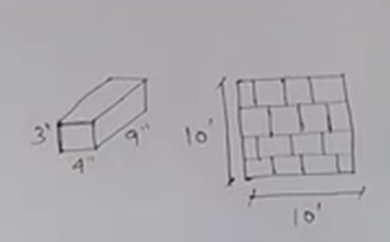

$$1) wall -10' x10'x9"$$
$$2) Size of brick -9"x4"x3"$$
$$3) Mortal thickness - 1/2" or 0.5"$$
$$4)volume of one brick with mortal=\frac{9.5\text{×4.5×3.5}}{12 ×12×12}=0.086 cft$$
$$5)volume of wall=10×10×0.75=75 cft$$
$$No of bricks =\frac{volume of wall}{volume of one brick with mortal}=\frac{75}{0.086}=872 \#$$
$$10\% wastage of brick=\frac{872}{10}=87.2 no=87 no$$
$total bricks=872+87=959 no$

$$1)volume of wall=10×10×0.75=75 cft$$
$$2)Total bricks=872$$
$$3)volume of one brick with out mortal=\frac{9\text{×4×3}}{12 ×12×12}=0.062 cft$$
$$Total volume of bricks=No of bricks×volume of one brick=872 ×0.062=54.06 cft$$
$$Volume of motor=Total volume of wall-Total volume of bricks$$
$$Volume of motor=75-54.06=20.94 cft$$
$$Dry motor value=Volume of motor+30\% \left(Volume of motor\right)=20.94+\left(0.3×20.94\right)=27.22 cft$$
$$4)Ratio =1:6=Cement 1:sand 6$$
$$cement=\frac{1}{7} \left(27.22\right)\left(\frac{1440}{35.32}\right)=158.5 Kg=\frac{158.5}{50}=3.17 bags$$
$$Sand=\frac{6}{7} \left(27.22\right)=23.33 cft=\frac{23.33}{100}=0.233 unit$$

